WEEK - 3
C++ Environment, IDE Installation and Tool Setup

Section 1.02 Installing and Configuring C++ IDE
We can get the appropriate installable for dev-C++ IDE from http://www.bloodshed.net/dev/devcpp.html Let’s see the entire installation process now. We have used the installable
that comes along with the C++ compiler. In this tutorial, we use the dev-C++ version 5.11 with the TDM-GCC 4.9.2 compiler. The stepwise installation for dev-C++ is given below.
1. The first step while we start the installer is to select the language of our choice as shown in the below screenshot.
2. Once you select the appropriate language, you have to agree to the license agreement that pop-ups next.
3. Next, we are asked to select the components that we need to install as a part of the dev-C++ installation. As shown in the above screenshot, we are provided with a list of components available for installation and a checkbox against each component. We can check/uncheck each box to indicate which components to install. Click next once the components are selected.
4. Now the installer prompts the user for the destination folder where the dev-C++ files/libraries etc. are to be copied. Once we provide the destination folder path, click on Install.
5. The following screenshot shows the progress of the installation. Once the installation is over, a ”finish” dialog that signals the end of the installation appears. We click finish and then we can launch the dev-C++ IDE. Now let’s see the working of this C++ IDE in detail.

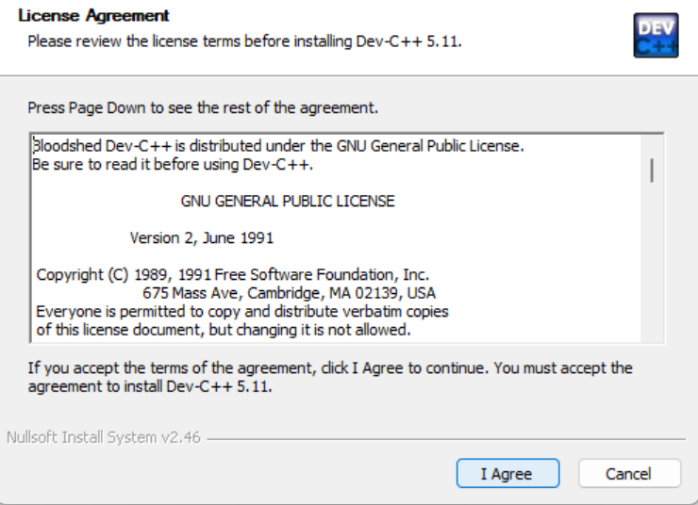
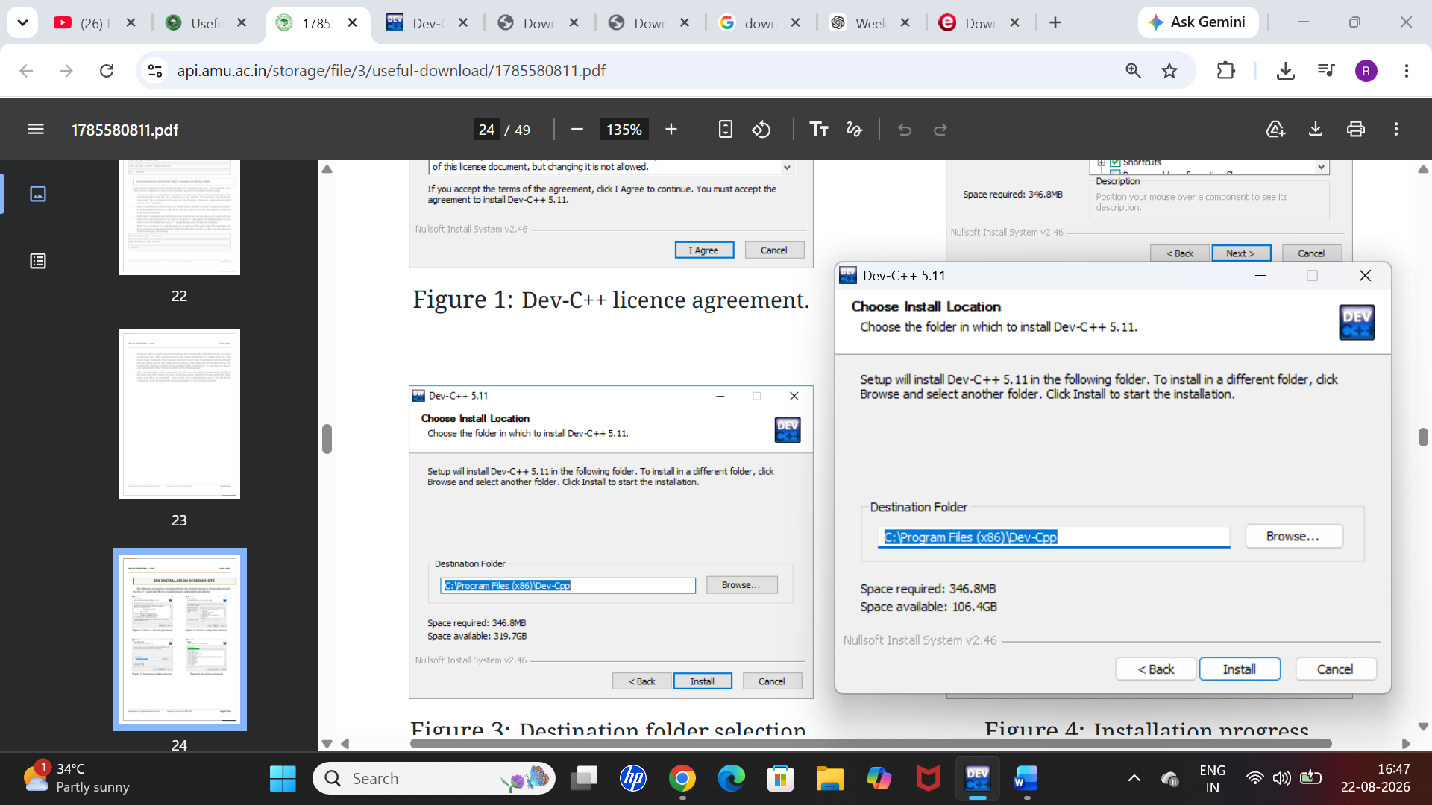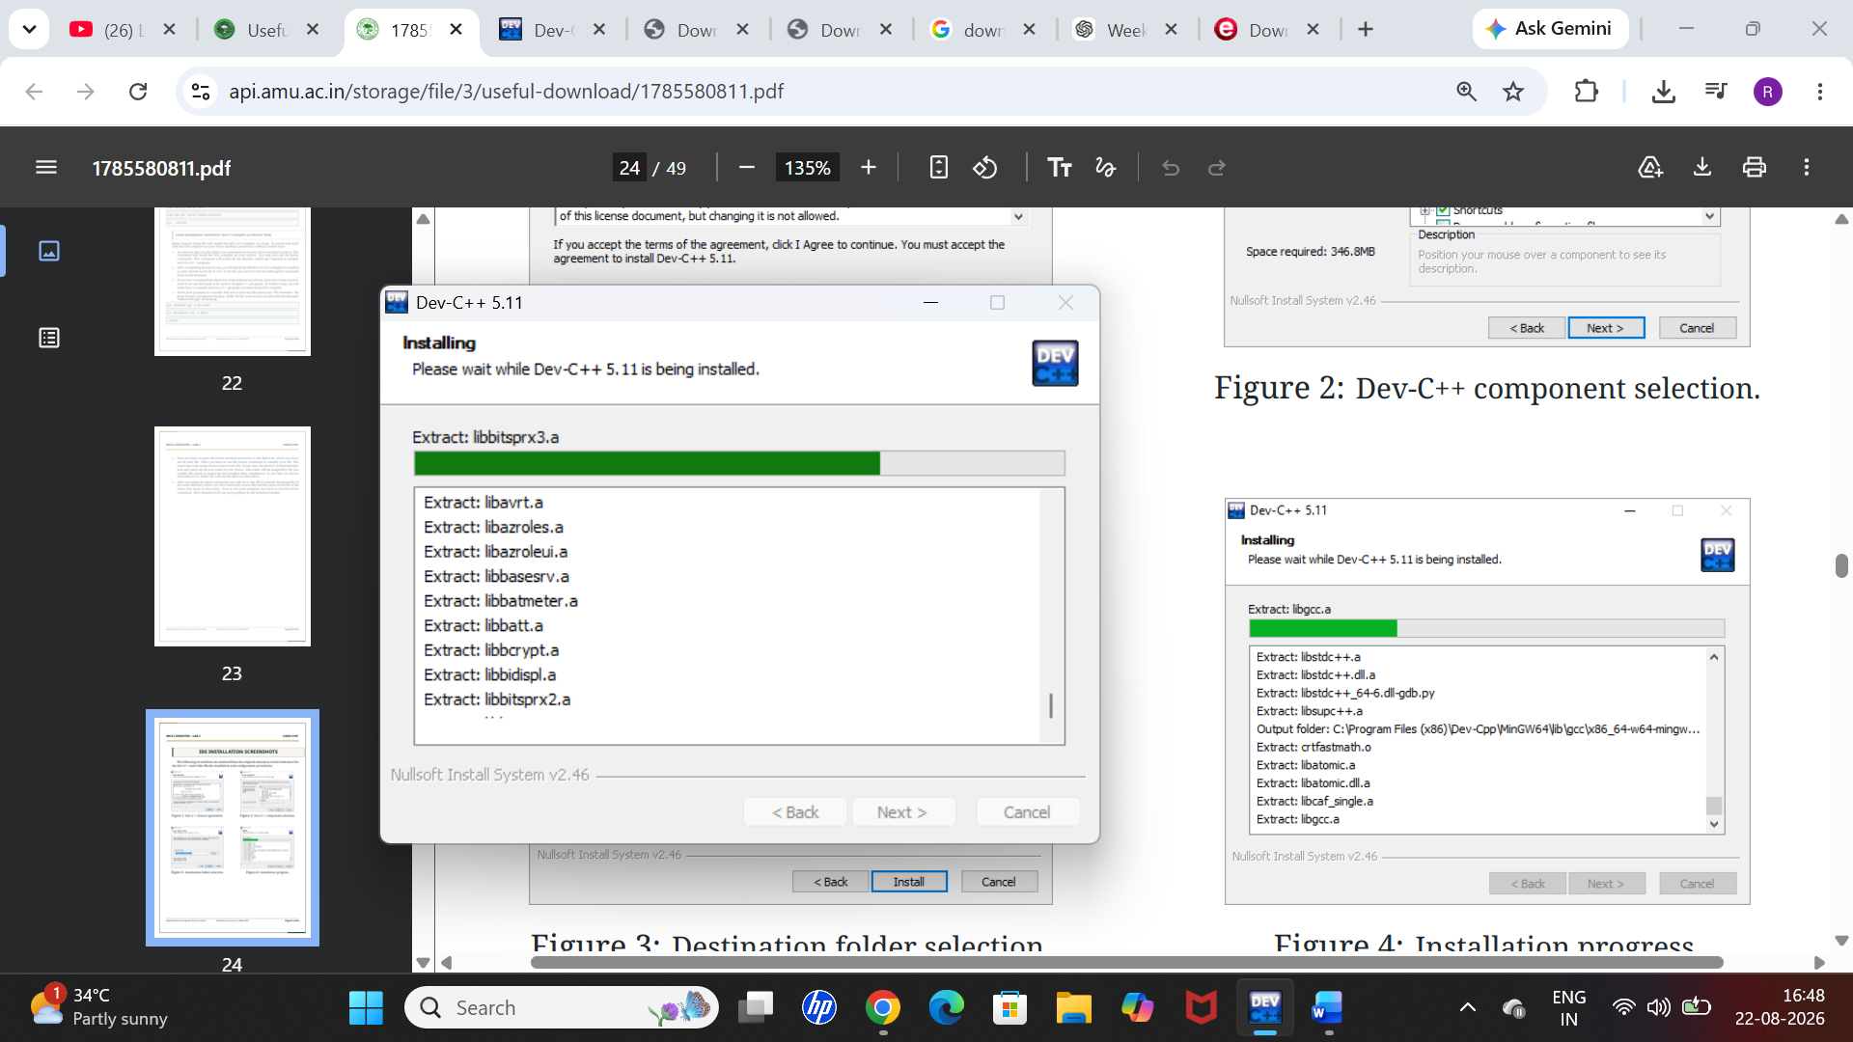

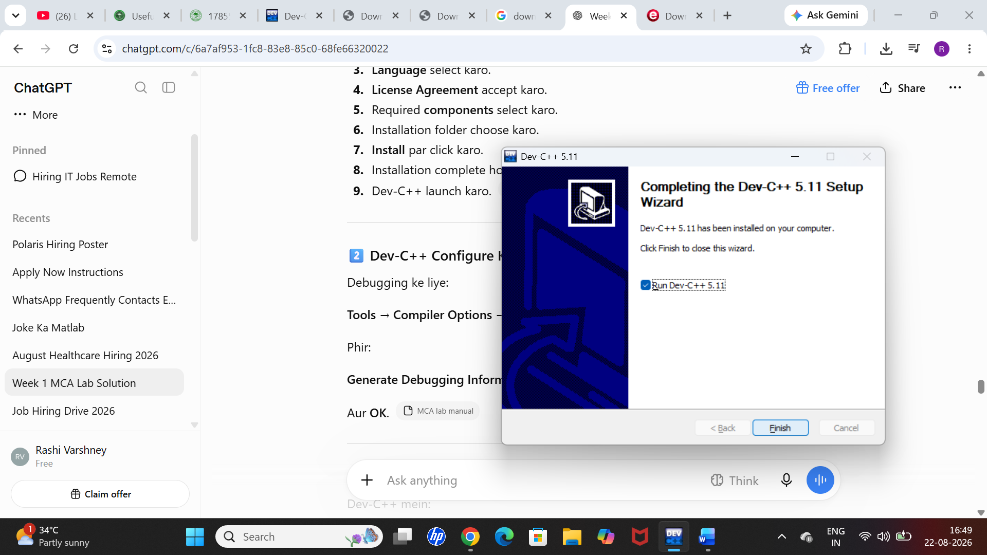

(a) Development Using Dev-C++ IDE
(b) Configuring Dev C++
(c) Change Linker Setting for Debugging
After starting the IDE, the first thing we need to ensure is the setting for debugging information
to be generated. Follow the steps below to set the debugging information.
▶ To change this setting, click on Tools → Compiler Options.
▶ Then click on the ”Settings” tab on the dialog that pops up.
▶ Under ”Settings”, we have a ”linker” tab.
▶ In the ”linker” tab there are various options shown. Set ”Yes” for the option ”Generate Debugging Information (-g3)”. This is shown in the following screenshot. Click OK, once done.
(d) Create a New Project
To create a new project in dev-C++ we need to follow the below steps
▶ Click File → New → Project.
▶ A new dialog opens up as shown below.
▶ Here, we can specify the project name. Make sure to select the ”Empty Project” and also to check the ”C++ Project” button.
▶ Once the entire information is provided, we can click ok and the IDE will ask for the path where the project is to be saved. When this is done, a workspace will open with the project explorer on the left-hand side that shows the project we just created.
▶ Now we can add or import the code files into this project.
(e) Add Source File(s)
Adding a file to a project can be done in two ways. 1. Add a new file by clicking Project
→New File or Right-click on Project Name in the project explorer and click New File. 2. Another way is to add the existing files to the project. This can be done by clicking Project
→Add to Project or right-click on Project Name in the project explorer and select ”Add to Project…” This will give a dialog to select files and import them to the project. 3. Once the files are added to the project, the workspace looks as shown below.
(f) Compile/Build & Execute Project
When we have all the code ready for the project, we will now compile and build the project. Follow the below steps to build and execute the dev C++ project:
▶ To compile the project, click Execute → Compile (or click F9).
▶ We can see the compilation status in the ”Compile Log” tab in the workspace.
▶ If there are any errors whether syntax or linker errors, then they will appear in the compiler tab.
▶ Once the project is compiled successfully, we need to run it.
▶ Click on Execute →Run. ( or click F10)
▶ The console window that gives us the output will be shown in the below screenshot.
▶ If there are command line parameters to be passed to the program, we click on Execute
→Parameters. This will open a dialog using which we can pass parameters.
(g) Debugging In C++ IDE
Sometimes we may not get the desired output from our program although the program is syntactically correct. In such a situation, we can debug the program. The
dev-C++ IDE provides the inbuilt debugger. Follow the below steps to debug the program
using Dev-C++ IDE:
▶ Click Execute→Debug. (or click F5).
▶ Once the debug is clicked, we get the debug menu in the IDE, as shown below.
▶ Before debugging we can toggle breakpoints using F4 at a particular line of code.
▶ Using the debug menu, we can use options like add watches, run to cursor, into function, etc. to efficiently debug our program.
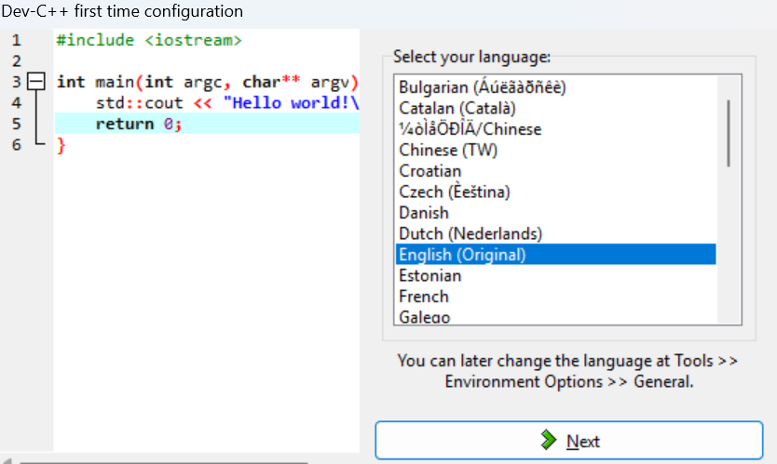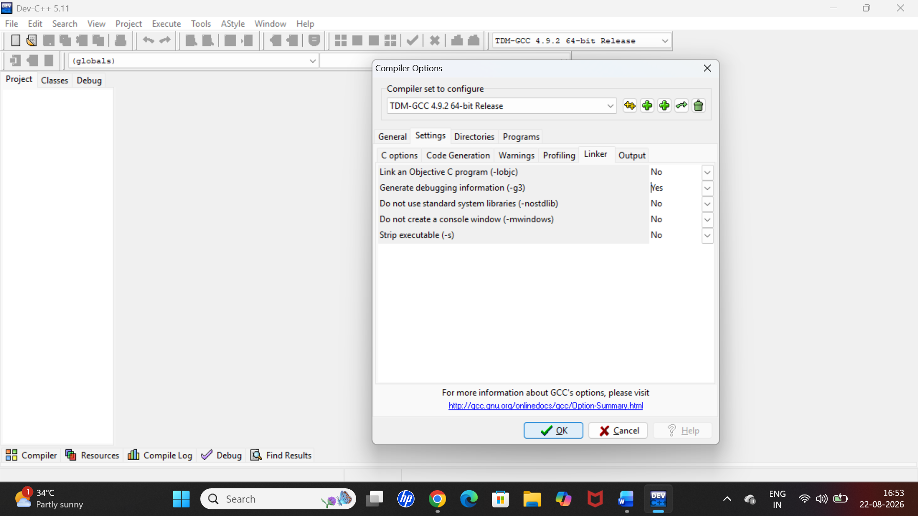

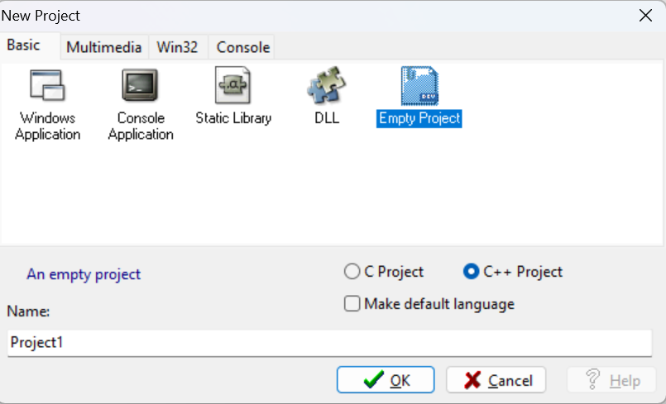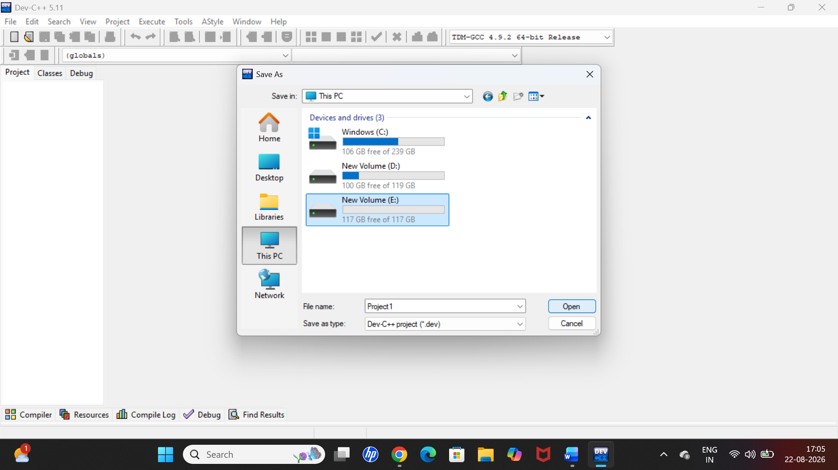

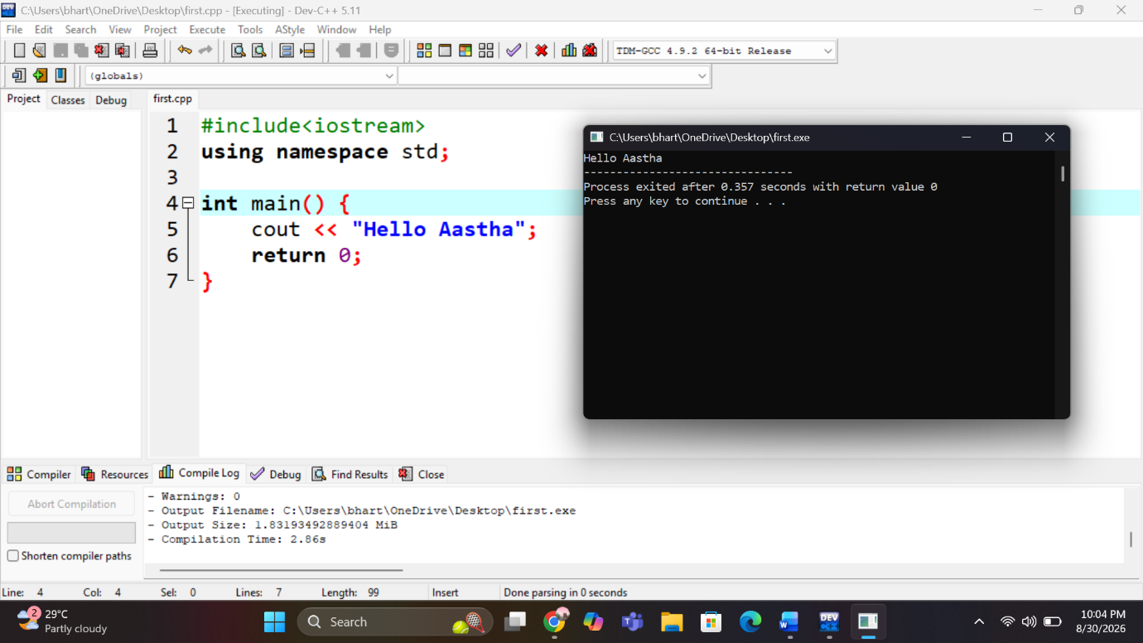

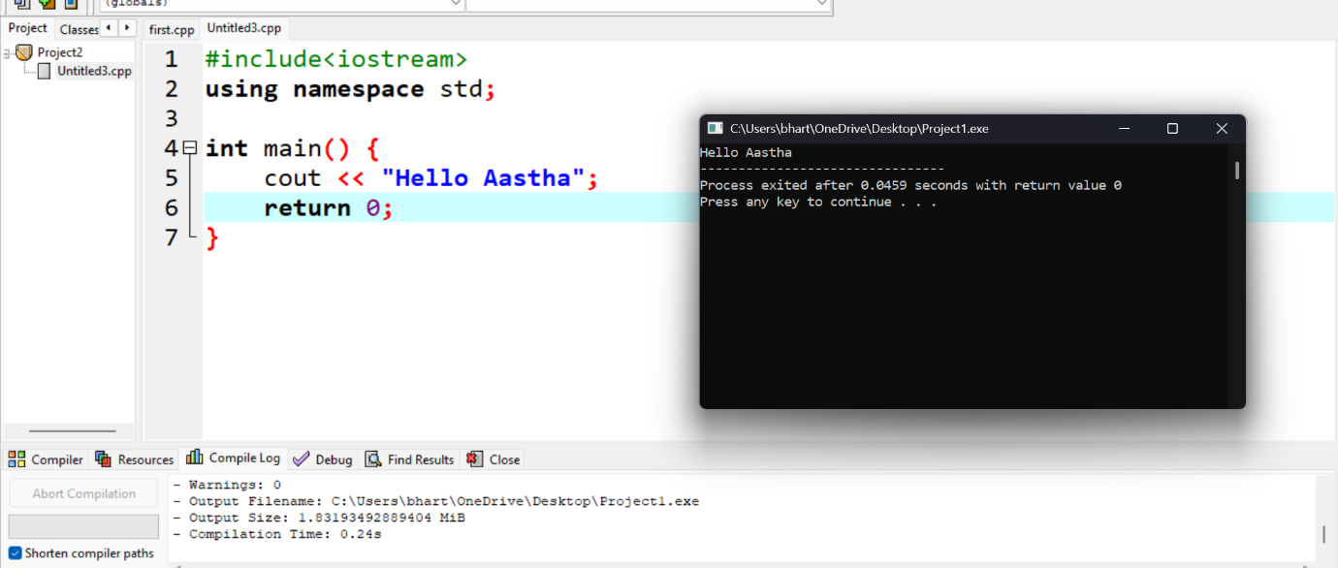

Article II. Setting up Code::Blocks on Windows
This tutorial gives you easy-to-follow instructions, with screenshots, for setting up a compiler (the MINGW compiler), a tool that will let you turn the code that you write into programs,
and Code::Blocks, a free development environment for C and C++. This tutorial explains how to install Code::Blocks on Windows 2000, XP, Vista or Windows 7.
Section 2.01 Step 1: Download Code::Blocks
▶ Go to this website: http://www.codeblocks.org/downloads
▶ Follow the link to ”Download the binary release” (direct link)
▶ Go to the Windows 2000 / XP / Vista / 7 section
▶ Look for the file that includes mingw in the name. (The name as of this writing was codeblocks-10.05mingw-setup.exe; the 10.05 may be different).
▶ Save the file to your desktop. It is roughly 74 megabytes.
Section 2.02Step 2: Install Code::Blocks
▶ Double click the installer.
▶ Hit next several times. Other setup tutorials will assume you have installed in C:\Program Files\CodeBlocks (the default install location), but you may install elsewhere if you like
▶ Do a Full Installation
▶ Launch Code::Blocks
Section 2.03Step 3: Running in Code::Blocks
You will be prompted with a Compilers auto-detection window: When you get the compiler auto-detection window, just hit OK. Code::Blocks may ask if you want to associate it as the default viewer for C/C++ files–I’d suggest you do. Click on the File menu, and under ”New”, select ”Project...” The following window will come up: Click on ”Console Application” and hit the ”Go” button. Click next until you get to the Language Selection Dialog: You’ll be asked to choose whether you want to use C or C++. If you’re not sure, use C++. Otherwise, choose based on the language you are learning. After clicking ”Next”, Code::Blocks will then prompt you with where you’d like to save the console application: I’d recommend you put it in its own folder, as it may create several files (this is especially true if you create other

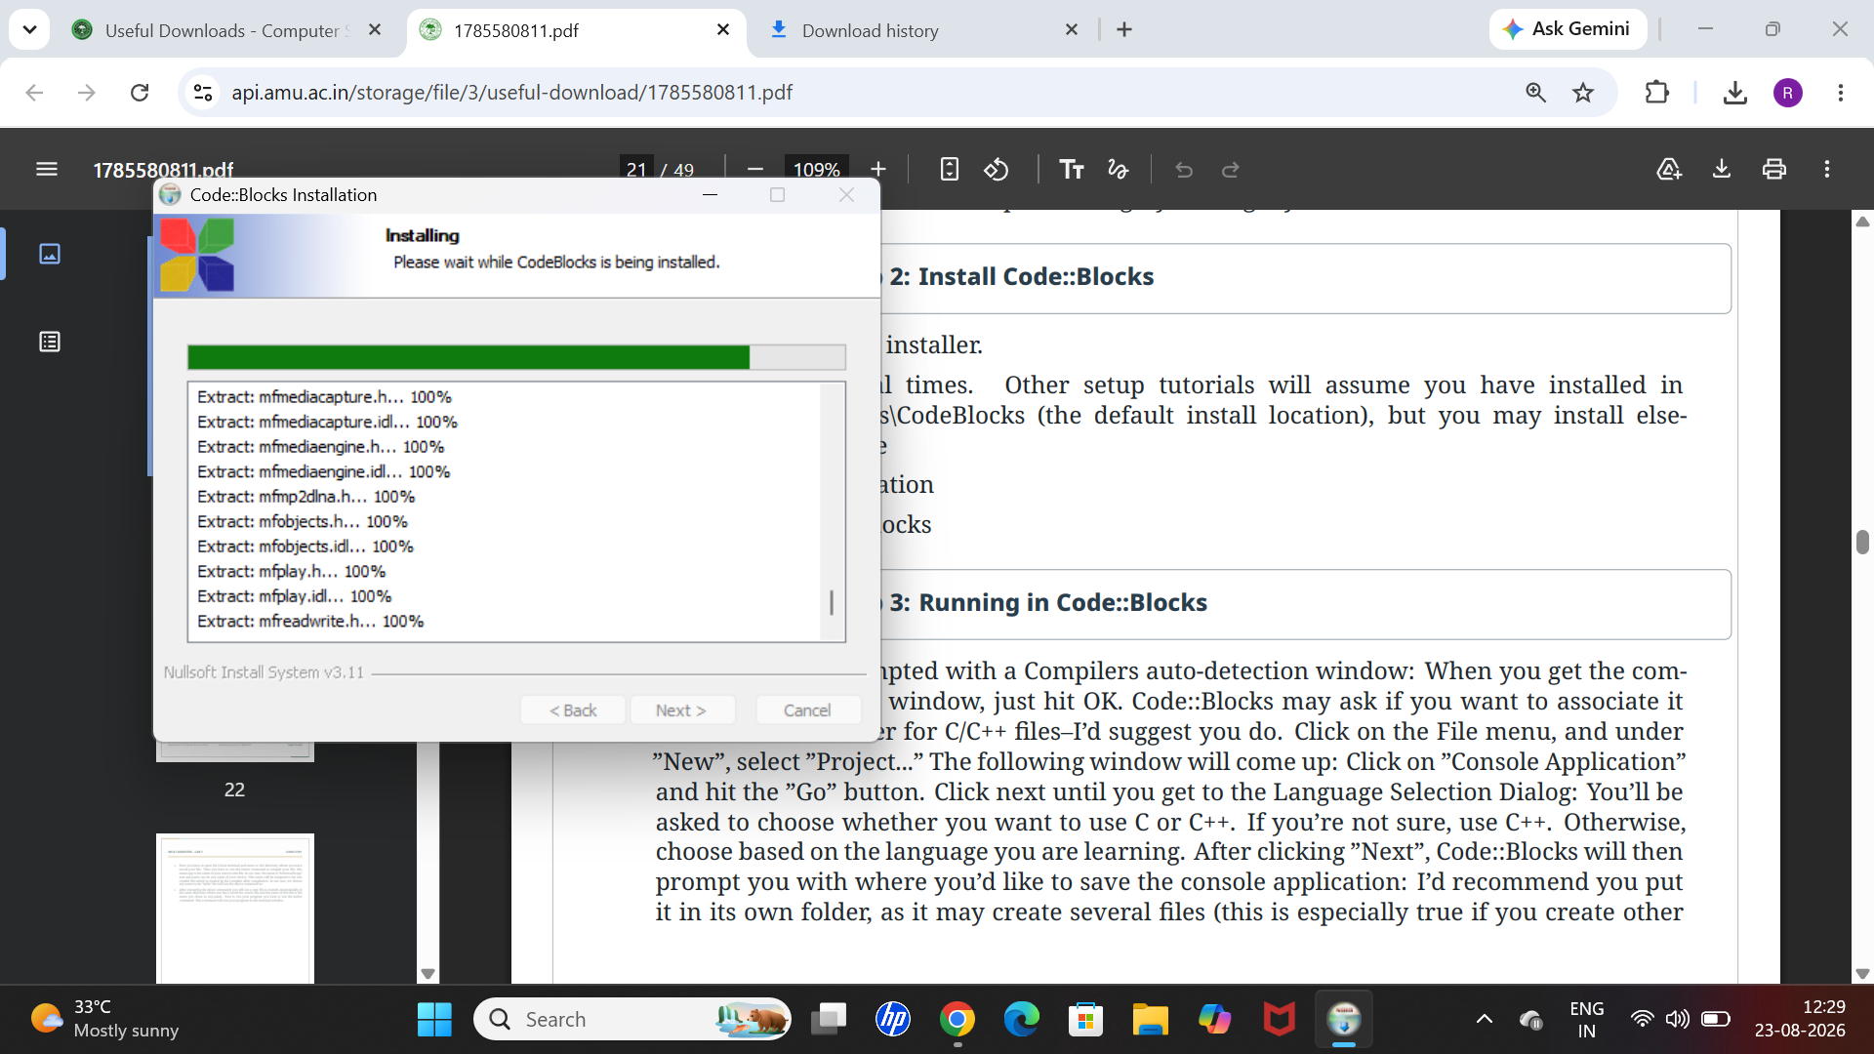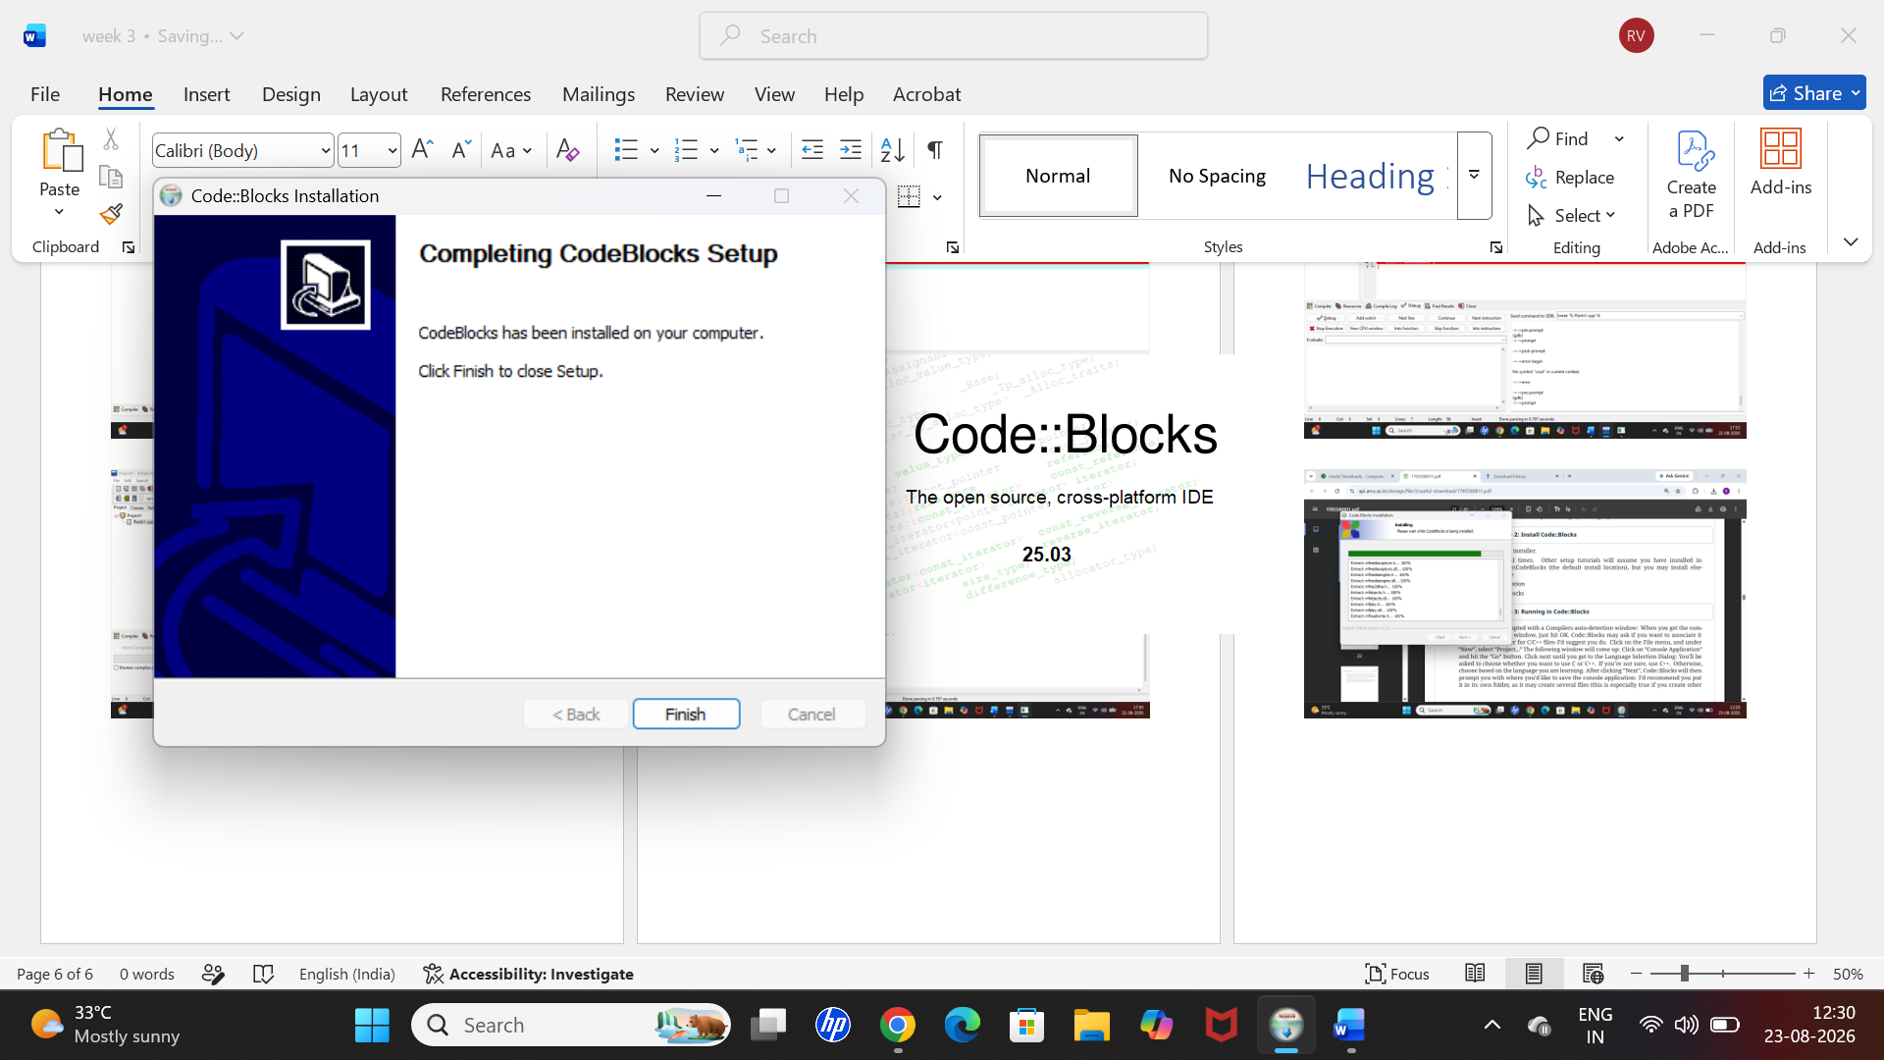

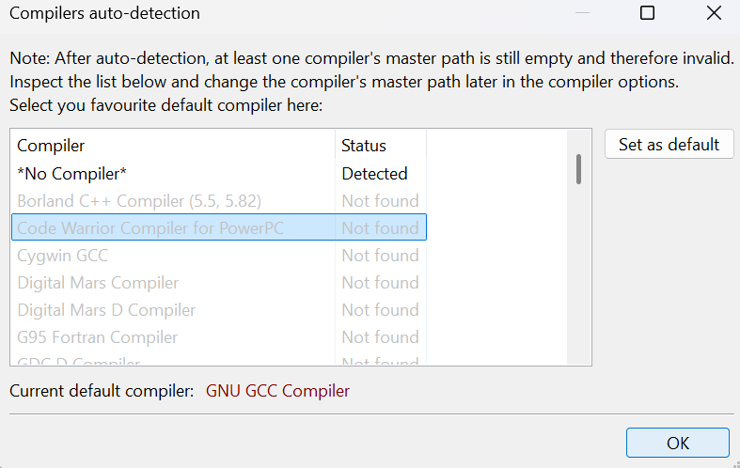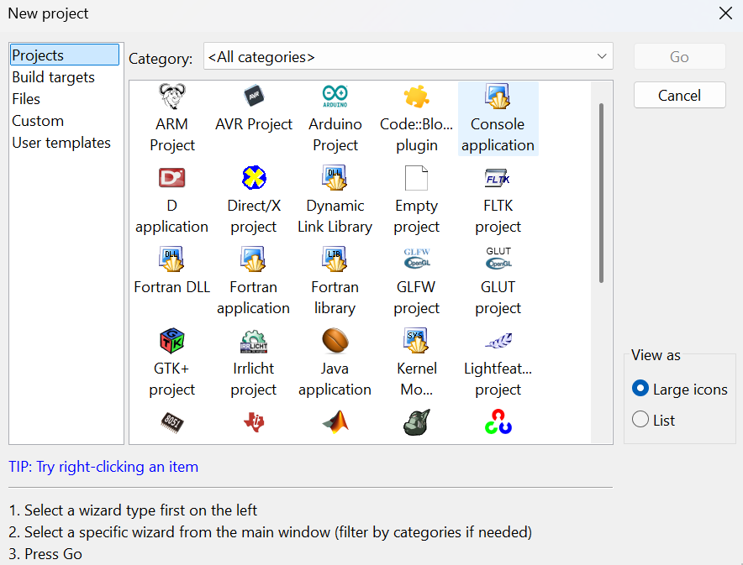

Linux Installation: Install GCC the C++ compiler on Ubuntu 18.04 Bionic Beaver Linux We will install the GNU GCC compiler on Linux. To install and work with the GCC compiler on your Linux machine, proceed according to below steps:
▶ You have to first run the below two commands from your Linux terminal window: This command will install the GCC compiler on your system. You may also run the below command: This command will install all the libraries which are required to compile and run a C++ program.
▶ After completing the above step, you should check whether the GCC compiler is installed in your system correctly or not. To do this you have to run the below-given command from Linux terminal:
▶ If you have completed the above two steps without any errors, then your Linux environment is set up and ready to be used to compile C++ programs. In further steps, we will learn how to compile and run a C++ program on Linux using GCC compiler.
▶ Write your program in a text file and save it with any file name and. CPP extension. We have written a program to display ”Hello World” and saved it in a file with the filename ”helloworld.cpp” on desktop.
g++ filename.cpp -o any-name
g++ helloworld.cpp -o hello
./hello
▶ Now you have to open the Linux terminal and move to the directory where you have saved your file. Then you have to run the below command to compile your file: filename.cpp is the name of your source code file. In our case, the name is ”helloworld.cpp” and any-name can be any name of your choice. This name will be assigned to the executable file which is created by the compiler after compilation. In our case, we choose any-name to be ”hello”.We will run the above command as:
▶ After executing the above command, you will see a new file is created automatically in the same directory where you have saved the source file and the name of this file is the name you chose as any-name. Now to run your program you have to run the below command: This command will run your program in the terminal window.

